’light Booking

nsert New Flight Details





$Jght BOoltiltg

E'° °'l -

## Passu-ord :—

ub Rene

’light Booking

AdonwLQgw

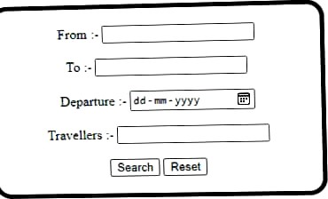

# -light Booking

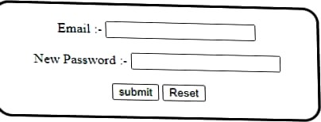





Flight Booking

There are no a› ailable flights

X @ Insert atle here X B FI\ghtBoobng ;'r B Insert title here X — 0 y



75• F -NG t7 33





locahod50S0 B /.,..aj LxrFaqe sp 

# Flight Booking

Lser Login

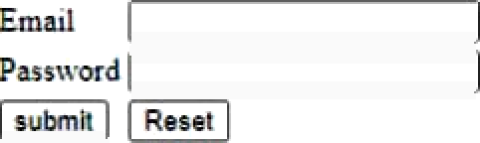

*?'’m• k’ser-Create account*

C'rea\e trrou nl

:..„..., :: *D* e + c a a B

FUght *Boolxiog*

